Networking Enhancement

for a GM1358 Sound Level Meter

(the swiss army knife)

Digest

There is a large choice of sound pressure level meters on the market, from pretty cheap to awfully expensive ones.  
The cheap ones have frequently a sufficient accuracy for many purposes (albeit not being suitable for a legal enforcement). Most of them have however either no, or extremely primitive reporting abilities.

The purpose of this development is to provide networking and reporting abilities as close to   
IEC 61672-1:2013 specifications as possible to an extremely cheap sound pressure level meter   
GM1358, by adding a ESP8266 WiFi microcontroller to it.

In the first variant sound pressure level meter + WiFi adapter + Online Dashboard the total value of the bill of material will be below 30€ !seitenzeh

The ESP8266 microcontroller will be small enough to fit into the original case of the GM1358 and the requested soldiering will be limited to three wires.  
With soldiering skills, you can do the job in less than 10 minutes.

Your modified GM1358 will then provide USB and WiFi connectivity and be programmable to do the coolest things that only high-end devices will provide:

Evaluation of the noise level according to following time response standards (simultaneously):

* Fast ( Attack t=125mS, Decay t=125mS)
* Slow ( Attack t=1S, Decay 4,3dB /sec)
* Impulse ( Attack t=125mS, Decay 2,9dB /sec)
* Real peak value by the minute ( 125mS resolution, not the maximum of readings)
* Background level (t=2000s, excluding NAT)

Statistics according to residential aircraft noise standards:

(steady noise equivalents)

* Leq 1 minute
* Leq for each hour of the day
* Leq for 24h
* Leq daytime 06:00 to 22:00
* Leq nighttime 22:00 to 6:00
* Leq 22:00 to 24:00
* Lden

(number above threshold)

* NAT for each hour of the day
* NAT for 24h
* NAT daytime 06:00 to 22:00
* NAT nighttime 22:00 to 6:00
* NAT 22:00 to 24:00

Additionally the program can grab weather information from openweathermap.org and provide the corresponding meteorological conditions.

1. You can report all this information over the USB port using a terminal program or the Serial Monitor of the Arduino IDE.  
   Over the Serial Plotter you can get a graphical output of the noise or battery evolution history:

## USB Sound Plotter from the Arduino IDE:

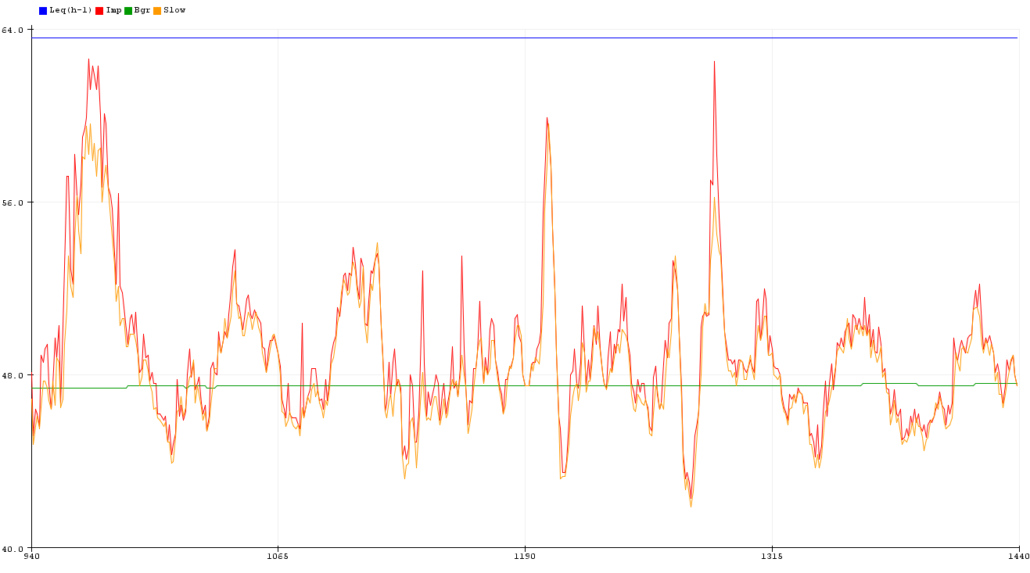

## USB Battery Plotter from the Arduino IDE:

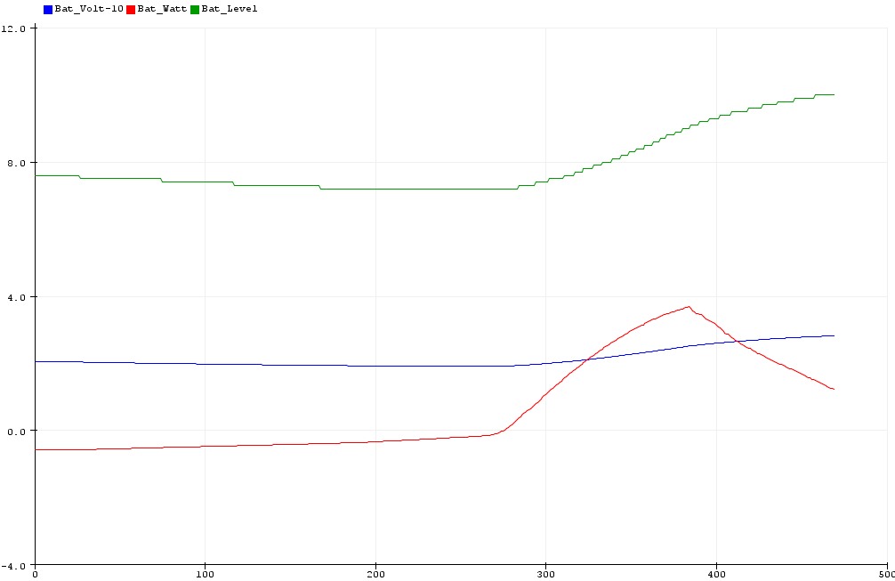

The plotter and reporting abilities of the Arduino IDE are however limited and you can only have one output at a time.  
With a free cloud service as e.g Thinger much more features can be used.

## Cloud service Thinger

You can register free to the Cloud service Thinger.io to plot information in a very versatile way.

You then can get fast real-time dashboards (that build up over time on screen) and also send information to data buckets from which you get historical data (immediately available)

Thinger real time sound plotter and weather information (example1)

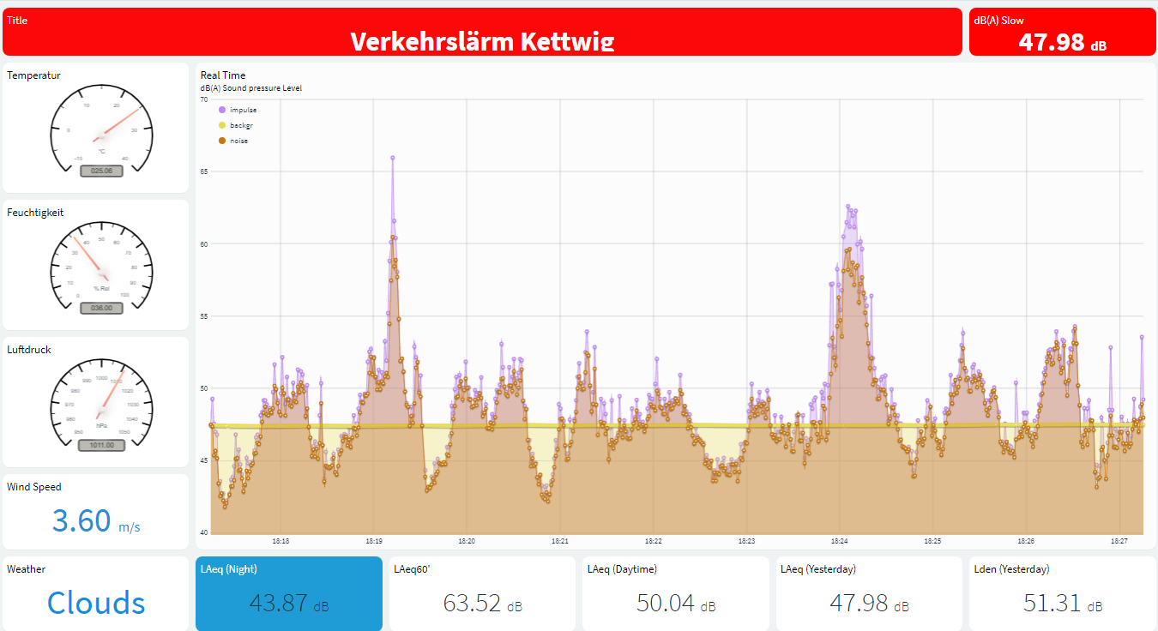

With solar hardware and a separate casing, you may also build the system with the ability to be solar powered including a solar power monitor to report all information about the battery condition and the power fed by the solar panel.

You will then operate the system without electrical connection to your computer, using the Cloud service Thinger.io.

Full extension with weather report, solar power report, noise level (needs solar hardware):

Thinger historical battery (example2)

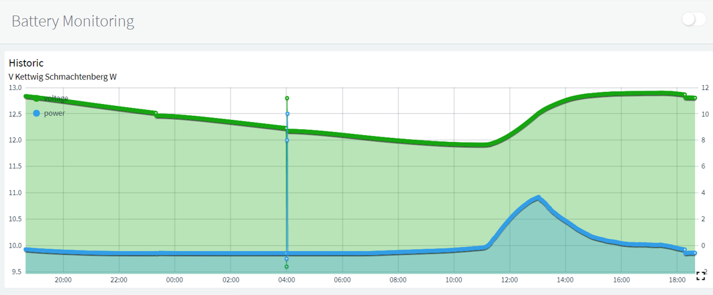

You can also build a split system with the SPL meter (+ the solar power circuitry) being located outside gathering and transmitting the sound (and battery) values over WiFi/ UDP   
(Long Range LoRa is planned)   
to another bare ESP8266 located inside that will provide the statistics over USB/ Thinger.

Last but not least, and back to the historical roots of the whole concept, the system is able to additionally to Thinger transmit over USB a single byte per second according to a proprietary   
"AK-Modulbus protocol" to a feeder program running e.g on a Raspberry Pi forwarding hourly reports to the European aircraft noise network . <http://www.eans.net/EANSindex.php>

This network is providing a very long time lobby-independent storage of aircraft/railway noise information managed by residentials, currently totaling about 700 privately and communal operated noise stations throughout Europa.

Noise record from DFLD/EANS. (Example3)

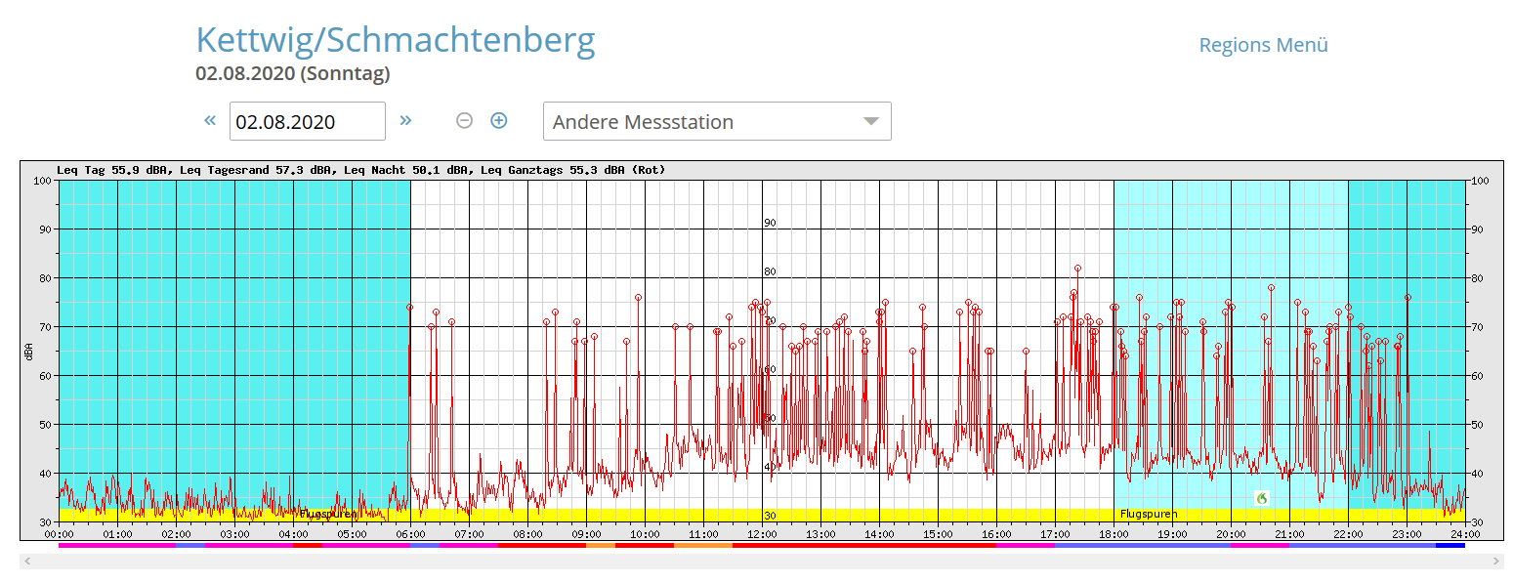

## Energy considerations

The built-in 9V alkaline battery block, provides about 24 hours of operation (@ 11mA).   
With the retrofitted ESP8266 the total consumption will be about 48 mA, which will drain the battery block within about 8 hours only.  
Fortunately, you can also power the system over the USB socket of the ESP8266 and provide over two days of continuous operation from a 3000mA lithium 18360 battery.

# Hardware schematics

## Simple version

Solar Powered Version with battery reporting  
If you want a 24/24/365 off-grid operation on solar power, depending on your location   
(e.g. at a 45° latitude) you will need a 12V 30Ah battery and (at least) a 20W solar panel,  
you can hardly imagine how little energy such as solar panel still delivers on a rainy winter day!

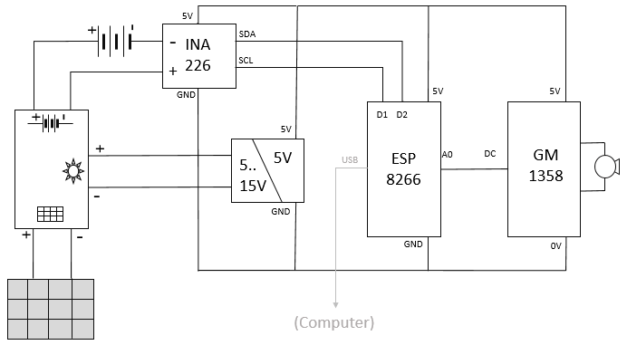

# Bill of material

## Simple version

You will need exactly that model of Sound level meter: GM 1358

Do not order another model!  
That one has the unique feature of providing a linear 0..1V DC signal output that is tied to GND   
and the ability to autostart when powered with 5V.   
It can interface with an ESP 8266 with only 3 wires.

You can find some devices on eBay.com, but you will find the best offers on AliExpress to largely varying prices. Anything below 30€ is OK…

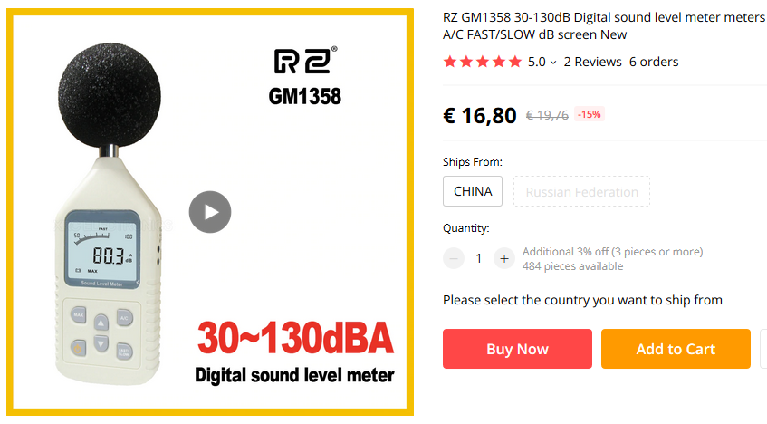

<https://www.aliexpress.com/item/1647511133.html>

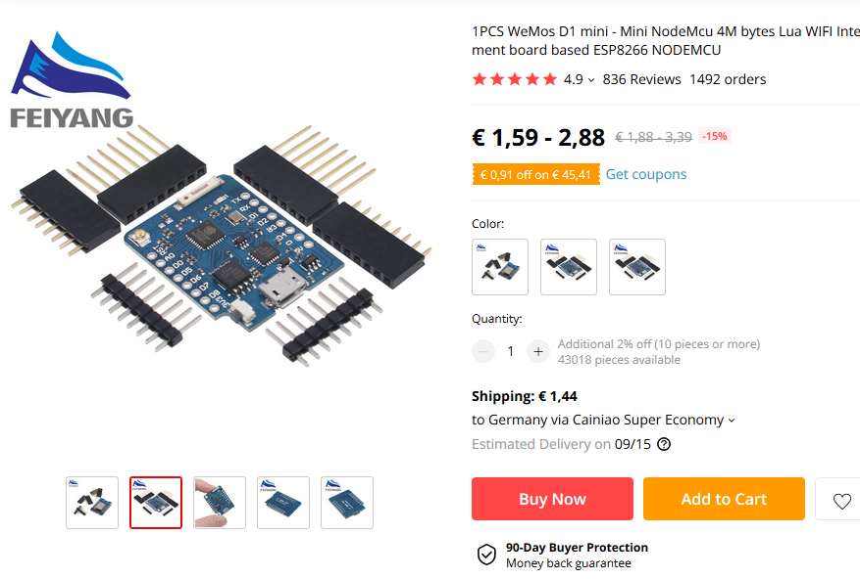

<https://www.aliexpress.com/item/32831353752.html>

## Option Solar power & monitoring

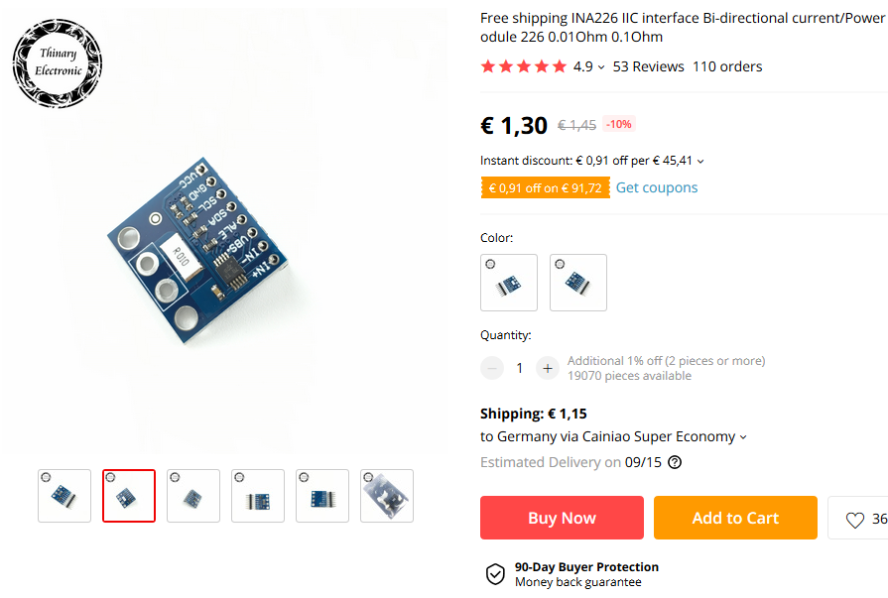

<https://www.aliexpress.com/item/32830512534.html>

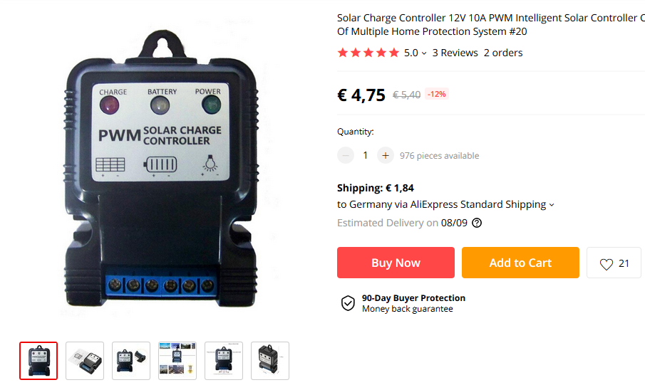

<https://www.aliexpress.com/item/4000083888167.html>

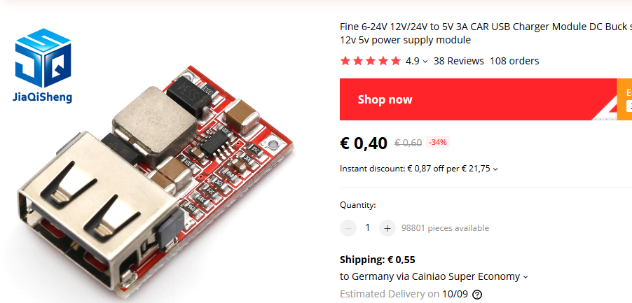

Order a **12V 12Ah or more lead acid battery** and a **20W or more solar panel** locally.

Take care to order solar suited batteries and solar panels with a glass front and an aluminum frame.

Avoid cheap solar stuff with resin front, they will decay within a few months in bright sun.

Here are some examples from Germany:

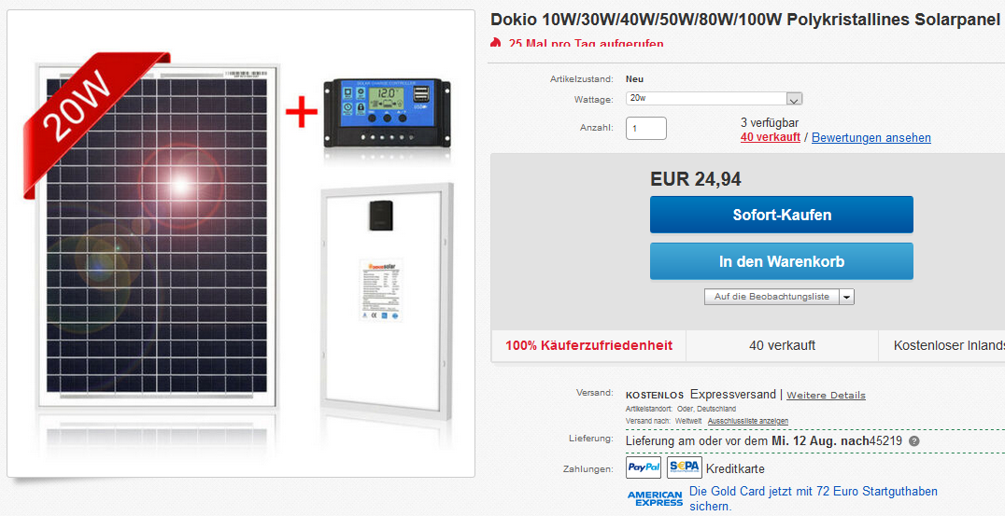  
(this combo-offer already includes the solar controller and even the USB 5V power supply)

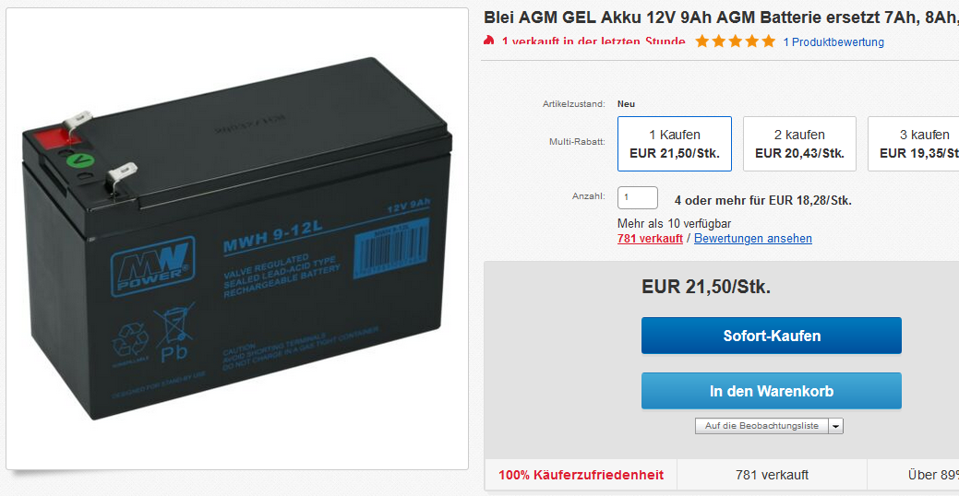

You may use an existing car battery if you have one in acceptable condition, but do not buy one:   
car batteries are not optimized for longer periods of operation with a voltage below 13,8v and will decay rapidly.

# Modification of the GM1358 Simple Version

The GM1358 is easy to dismantle, remove 4 screws: 2 at the top and 2 in the battery compartment and you can open the casing.

The first thing might sound scaring but it is easier as it looks: we need to bridge one very tiny resistor on the ESP8266 to change the input range from 0..3.3V to 0..1V.

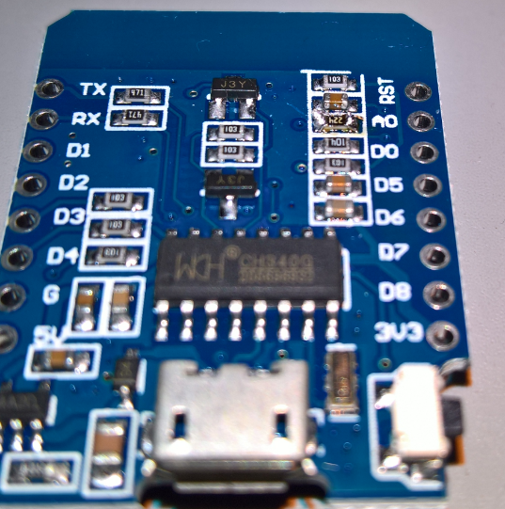

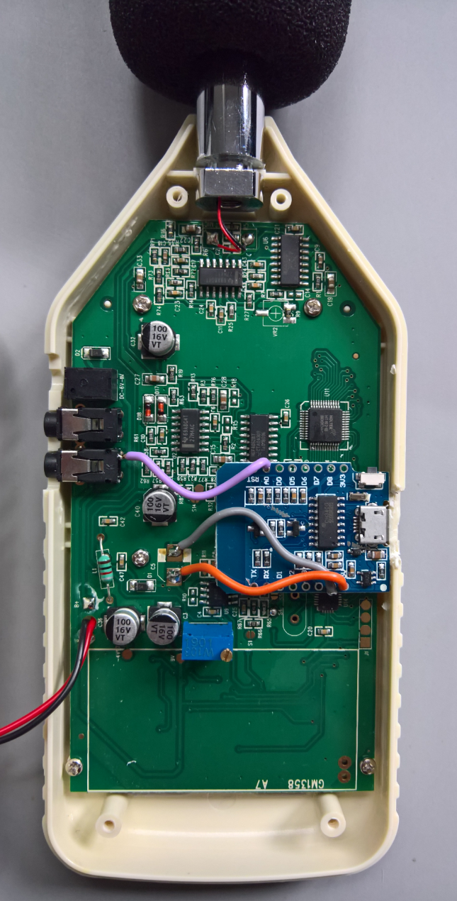Take a single strand of electrical wire and solder it to bridge the resistor close to A0 as shown:

Solder the grey wire to GND and the pad on the PCB board, solder the orange wire to GND and the pad on the PCB board, solder the pink wire to A0 and the inside contact of the DC jack  
Grind the plastic case to free room for the USB plug.  
Glue the ESP8266 as shown.  
Screw the case back. Done!

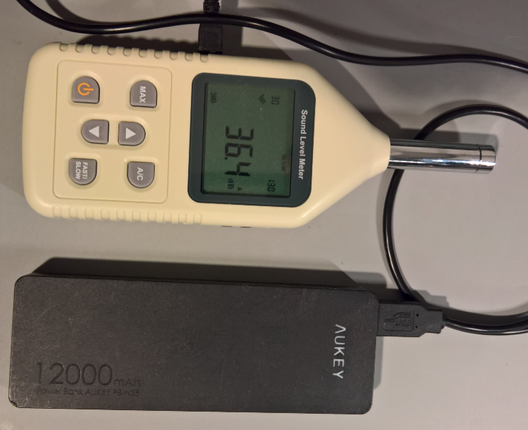

## Outdoor / Solar Version

to be described in detail later…

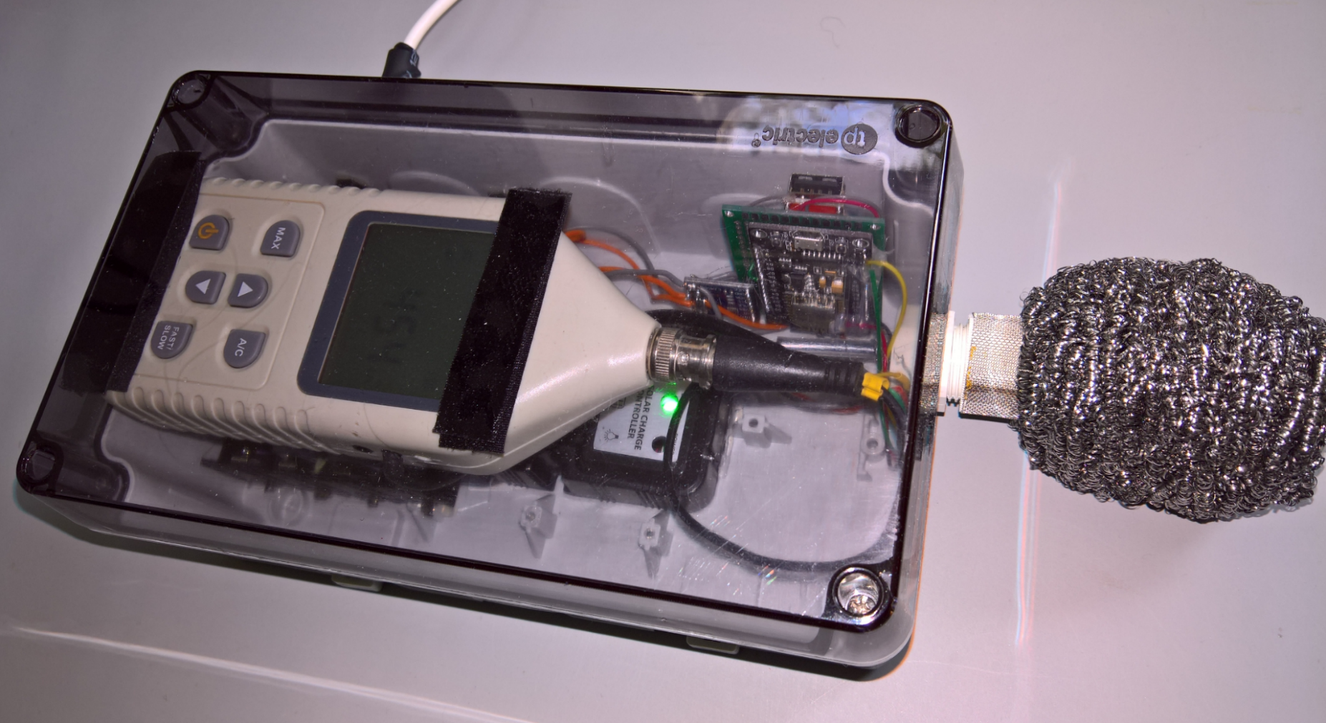

# Software

To operate the noise station you will need a WLAN connection and internet connectivity.

You will need to upload the program to the ESP 8266.   
For that, if you don't have it already, you should install the Arduino programming Interface (IDE) from www.arduino.cc <http://www.arduino.cc>, on your favourite PC, and then install the ESP framework.

Cf these instructions: <https://randomnerdtutorials.com/installing-the-esp32-board-in-arduino-ide-windows-instructions/>

Optionally you could register to two free services:

The first step will be to create a free account at www.thinger.io <http://www.thinger.io>   
(you can manage two devices free of charge) and   
optionally create a free account at www.openweathermap.org <http://www.openweathermap.org> if you want to get weather information for your location.

The current files of my program are hosted on GitHub:  
<https://github.com/rin67630/Swiss-Army-Knife-for-GM1380-Sound-Pressure-Meter>   
You may download all .ino files in a folder of your choice and start the Arduino IDE:

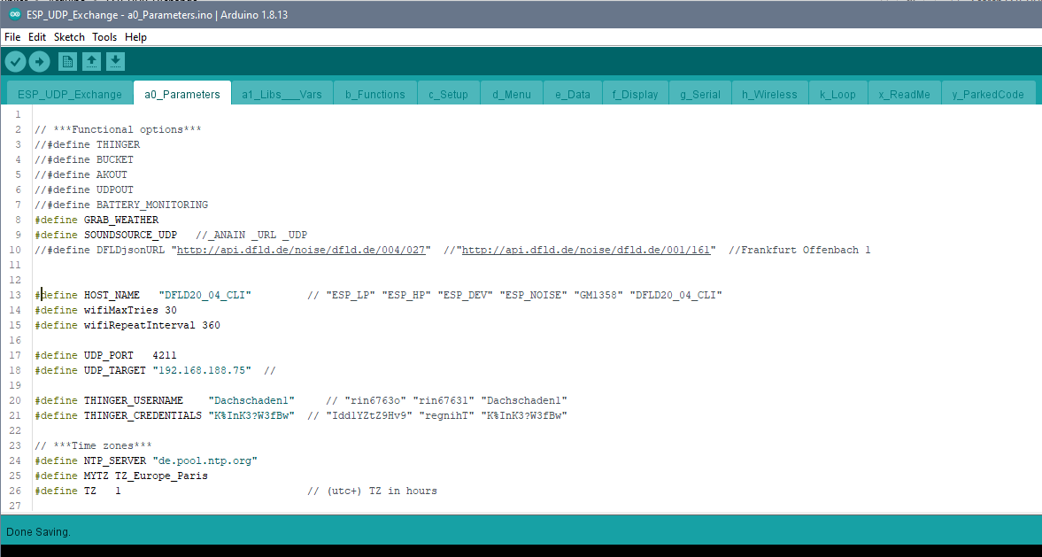

I have built the program on the top of my framework ESP-Krarajan on GitHub: <https://github.com/rin67630/ESP-Karajan> , which takes care of ancillary tasks like, booting to the network and providing scheduling and timing functionalities.

The Arduino IDE provides tabs to split the program into well-structured subparts, so you can jump easily during development between every subpart:

a0) parameters and options to use the program *(the only part you really need to modify)*

a1) libraries and global variables used

b ) different functions used in the program

c ) setup process

d ) menu

e ) data processing

f ) display (not used here...)

g ) serial reports

h ) wireless processes

k ) finally the scheduler itself which will periodically start the routines listed from d) to h).

Additionally two tabs with comments only are added for convenience:  
x_ReadMe and y_ParkedCode, where you can put reminders and code examples.

In my programming style, I deliberately refrain to use too abstract c++ concepts in order to make the program accessible to the majority of people with a minimum of Arduino experience.   
I also did put a great attention to comment my code indicating the reason why I have done most steps in that way.

## USB-Serial Menu

The Software provides a simple “single character” command-line menu over the USB serial line.

Commands are given by a single character and executed over [return]  
Commands are stackable: you can give several characters then [return]; all commands will be executed in sequence.

Example: U+++ means: Apply 94&47dB Defaults and Increase Offset by 3dB.

Usually an upper case letter sets the function and the lower case reset the function.

### Control actions

'Z': //Reset the ESP device

'C': //Apply 94dB Calibration

'c': //Apply 47dB Calibration

'U': //Apply 94&47dB Defaults

'+': //Increase Offset by 1dB

'-': //Reduce Offset by 1dB

### Control Display

(could be re-implemented, would need a display, Thinger is more powerful and needs no hardware)

'0': //Display mode 0

…

'3': //Display mode 3

### Periodical reports over the USB serial line

'A': //serialPage AK   
 *(this is not a printable report, it issues one byte every second to feed the DFLD website)*

'P': //Periodical Reports on 'p': //Periodical Reports off

Options for periodical reports:

'D': //Day Report 'd': //no Day Report

'H': //Hour Report 'h': //no Hour Report

'M': //Minute Report* 'm': //no Minute Report (Battery)

'S': //Second Report* 's': //no Second Report (Noise)

'E': //Event Report 'e': //no Event Report

* these reports are designed to produce serial Plotter compatible results.

Example1 : PDHmsE means: Print Daily, Hourly, no minute, no second, Events

Example 2: p means: stop printing reports.

Example 3: P means: resume printing reports with last options

Example 4: Sd means: now with Second reports without Daily reports.

### One shot reports

n.b. these reports stop periodical reports, resume with “p” to return to periodical printing.

'L': // Leq by 24h Report

'N': // NAT by 24h Report

'B': //Battery by 24H Report

'b': //Battery Report (Actual measurements)

'?': //List parameters  
'~': //List WLAN / Radio settings.

# Report examples

## Minute Hour and Events

Menu command MHEP:

08:55:59.490 -> Bat_Volt-10:1.928 Bat_Watt:-0.593 Bat_Level:7.200

08:56:59.461 -> Bat_Volt-10:1.927 Bat_Watt:-0.593 Bat_Level:7.200

08:57:59.462 -> Bat_Volt-10:1.926 Bat_Watt:-0.593 Bat_Level:7.200

08:58:59.502 -> Bat_Volt-10:1.925 Bat_Watt:-0.593 Bat_Level:7.200

08:59:59.489 -> BatAhBat:0.000 A0dBLEQ:58.8 WindSpeed:0 Direction:1072693248

08:59:59.536 -> Bat_Volt-10:1.924 Bat_Watt:-0.593 Bat_Level:7.200

09:00:59.478 -> Bat_Volt-10:1.923 Bat_Watt:-0.593 Bat_Level:7.200

09:01:59.466 -> Bat_Volt-10:1.922 Bat_Watt:-0.593 Bat_Level:7.200

09:02:47.466 -> PKTm: 09:01:37 PKdB:52.8 ATdB: 50.2 ATsec:48 PK-10dB: 49.7 PK-10sec: 41 NAT:1

09:02:59.489 -> Bat_Volt-10:1.921 Bat_Watt:-0.593 Bat_Level:7.200

09:03:59.488 -> Bat_Volt-10:1.920 Bat_Watt:-0.593 Bat_Level:7.200

Menu command L:

Leq : for Saturday, 08 August 2020

Hour | 00 | 01 | 02 | 03 | 04 | 05 | 06 | 07 | 08 | 09 | 10 | 11 |

Leq dB | 58.1 | 58.3 | 58.3 | 58.4 | 58.4 | 58.5 | 58.6 | 58.7 | 58.8 | 61.1 | 65.4 | 65.8 |

Hour | 12 | 13 | 14 | 15 | 16 | 17 | 18 | 19 | 20 | 21 | 22 | 23 |

Leq dB | 66.0 | 66.2 | 66.3 | 62.9 | 63.2 | 63.6 | 63.8 | 54.0 | 56.3 | 56.6 | 57.3 | 57.8 |

Menu command N:

NAT : for Saturday, 08 August 2020

Hour | 00 | 01 | 02 | 03 | 04 | 05 | 06 | 07 | 08 | 09 | 10 | 11 |

NAT | 00 | 00 | 01 | 00 | 01 | 00 | 00 | 00 | 00 | 01 | 24 | 23 |

Hour | 12 | 13 | 14 | 15 | 16 | 17 | 18 | 19 | 20 | 21 | 22 | 23 |

NAT | 20 | 21 | 19 | 06 | 12 | 09 | 34 | 12 | 13 | 01 | 01 | 00 |

Menu command B:

Battery History :

Hour | 00 | 01 | 02 | 03 | 04 | 05 | 06 | 07 | 08 | 09 | 10 | 11 |

Bat Ah | -0.045 | -0.047 | -0.048 | -0.048 | -0.048 | -0.048 | -0.048 | -0.049 | -0.049 | +0.000 | +0.000 | +0.000 |

Hour | 12 | 13 | 14 | 15 | 16 | 17 | 18 | 19 | 20 | 21 | 22 | 23 |

Bat Ah | +0.000 | +0.000 | +0.000 | +0.000 | +0.000 | +0.000 | +0.000 | +0.000 | -0.044 | -0.044 | -0.044 | -0.044 |

To hold the solar panel: <https://www.thomann.de/de/thomann_orchesterpult.htm> ~15€

To hold the elcronics and battery: <https://www.thomann.de/de/flyht_pro_uac_universal_alu_case_s.htm> ~50€